During breakfast on Saturday morning (day of investigation), Amanda drew the above face of a man that she was seeing. She described him as “A man from the water,. Slimy. Missing an eye. Decaying. Light brown , straight hair. Longer on top.”

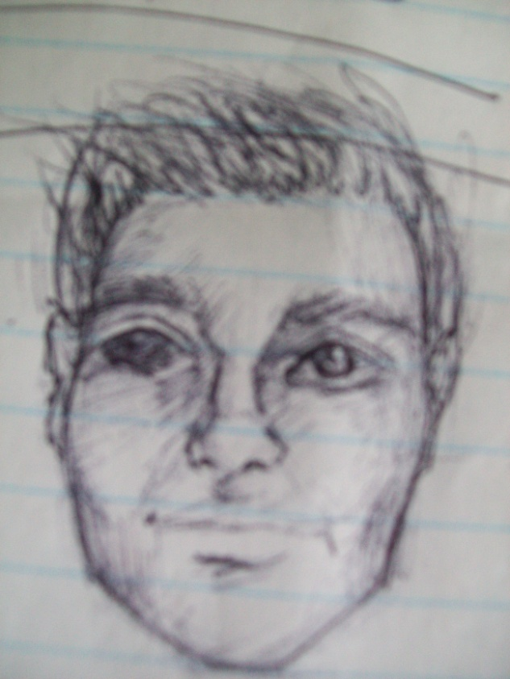

The above picture is of a man named Steven. Steven fell out of a boat in June 2007 in Bala. He was found a few days later in Lake Muskoka, deceased.
Notice the similarities between Amanada’s sketch and the above picture?

